Collection of the second seminar

Topic:
Provision of the social services - the main principles of operation of these services in the partner countries, the main weaknesses and the main advantages of 'national' approaches. Tasks of public administration and regional authorities in this field, an initiative of NGOs and their ability to effectively operate in the field of social services. The social services and public budgets.

7. – 8. 10. 2014, Brno

Content
1. Social services in Germany, the use of IT technology in social and health services – T-SYSTEMS INTERNATIONAL GMBH, Bonn 3
2. Payment of the allowance for care under conditions of the Czech Labour Office 18
3. The current situation in the field of social services in the city of Brno 21
4. The non-profit sector and social services 28
5. Social services in the South Moravian Region 30
6. BETANIE – Christian Aid 40
7. The provision of social services in Slovakia – the basic principles 46
Sources 57

Social services in Germany, the use of IT technology in social and health services – T-SYSTEMS INTERNATIONAL GMBH, Bonn
Ing. Josef Filip

Significant changes in the lifestyle of present generations
- Technology and current information within easy reach of every individual
- High general level of education, labour migration and loosening of classical family,
- Urban lifestyle, sport, sports, and culture in everyday life, aging population
- Changes in the value system
- Longer active life
- Multinational companies - clients and employees around the world - connecting cultures
  - Global thinking
  - Global responsibility, security solutions
The Pan – European health network
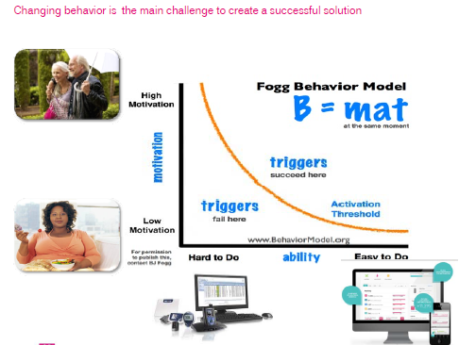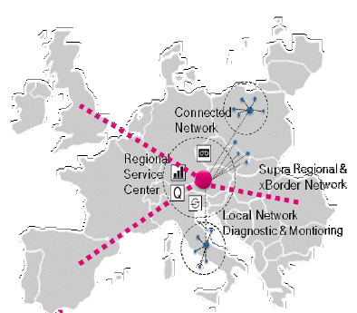

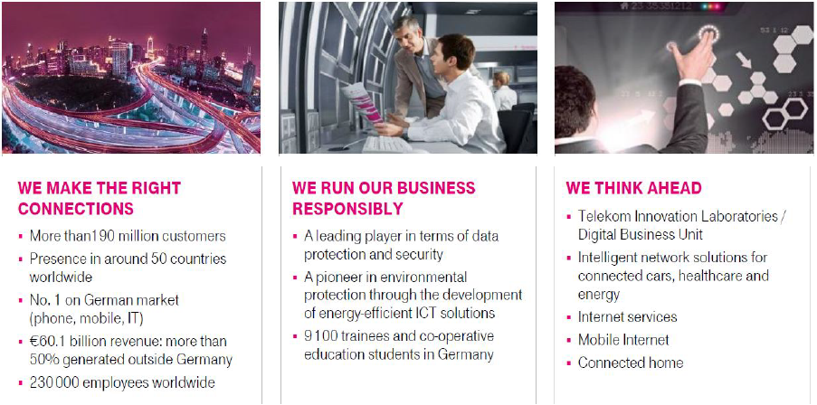
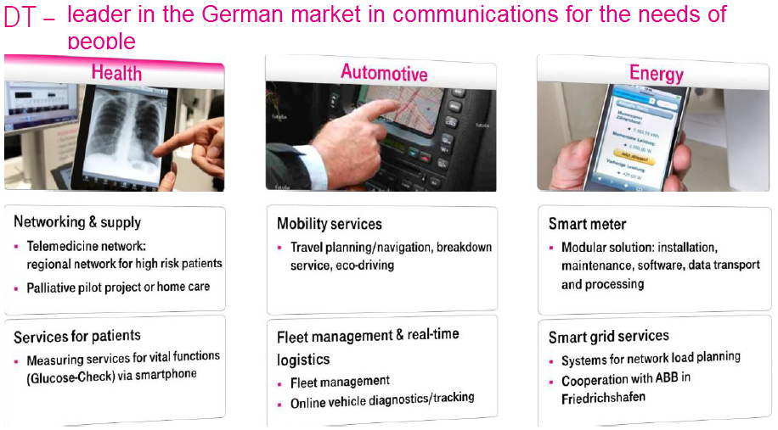
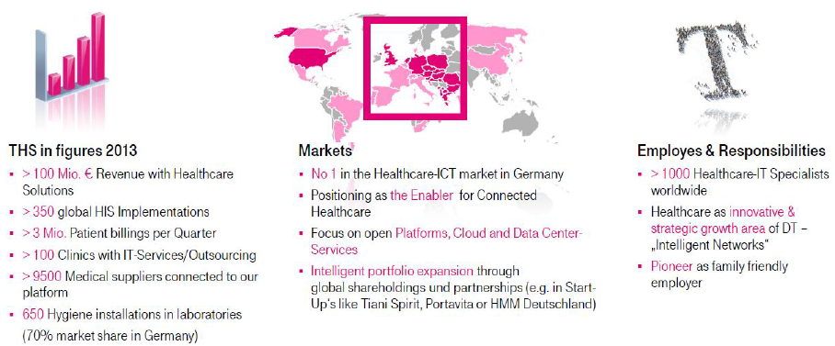
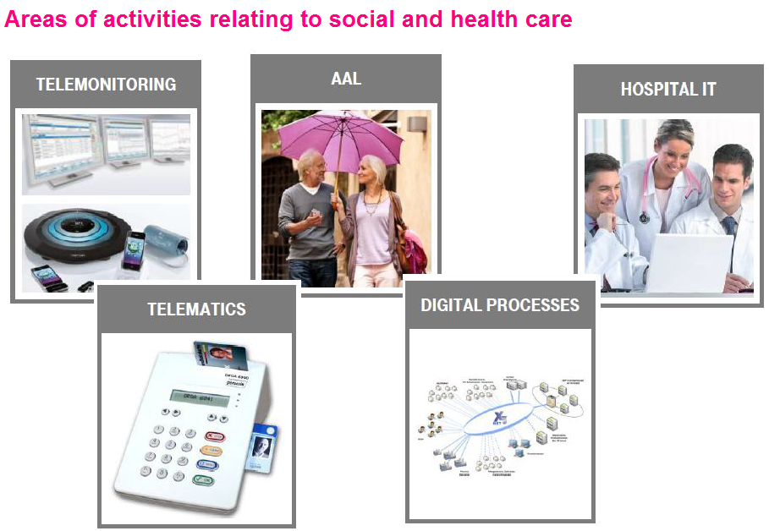
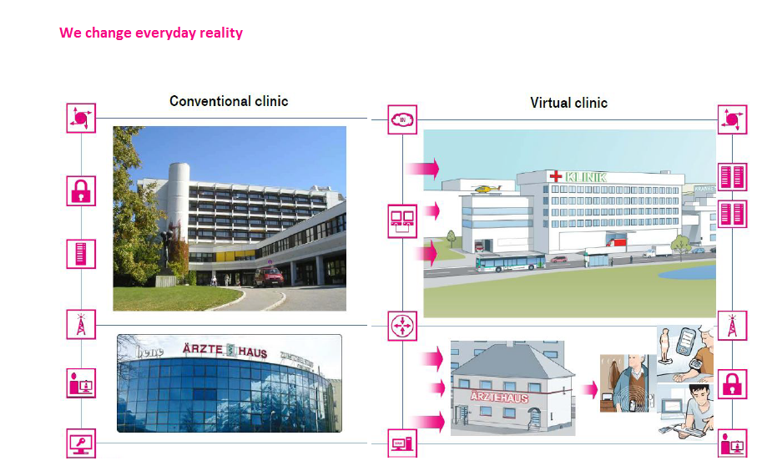

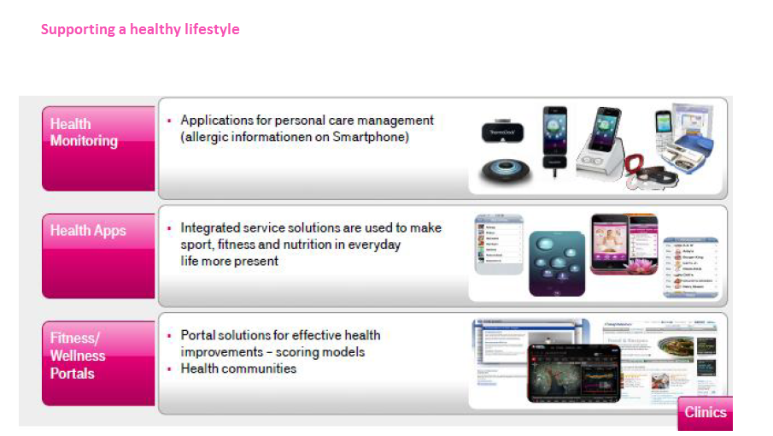
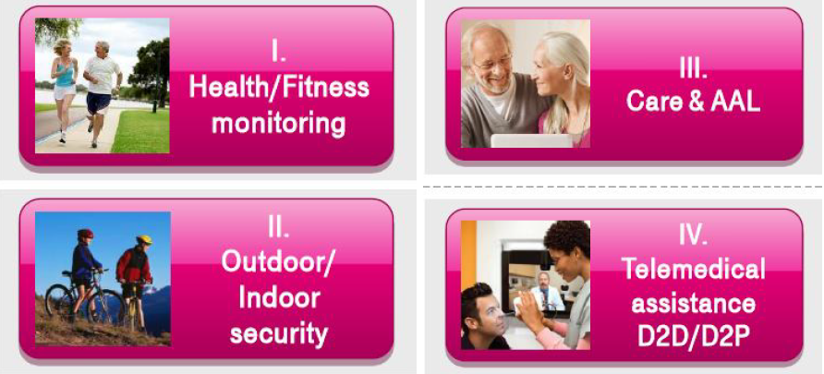

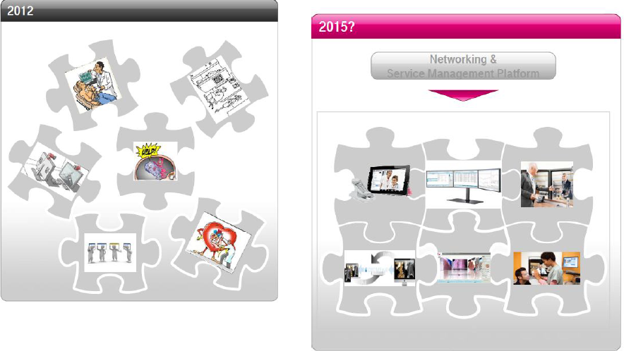
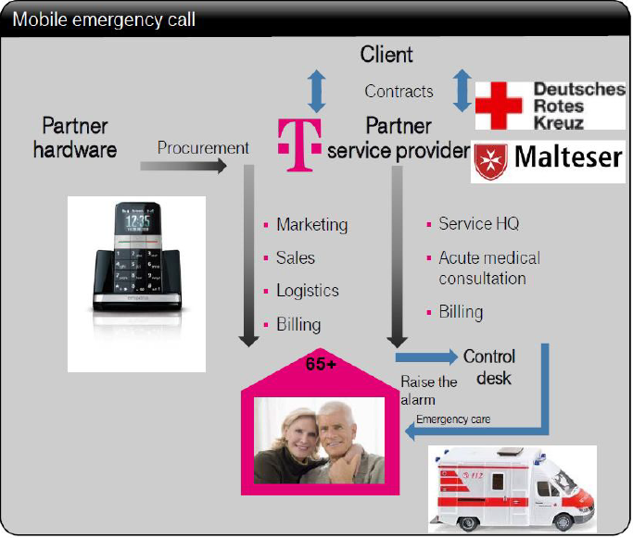
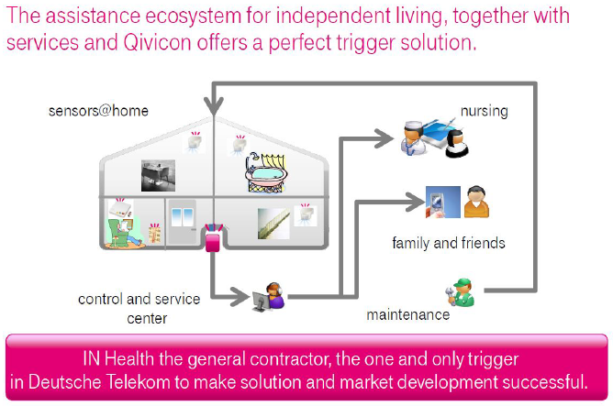
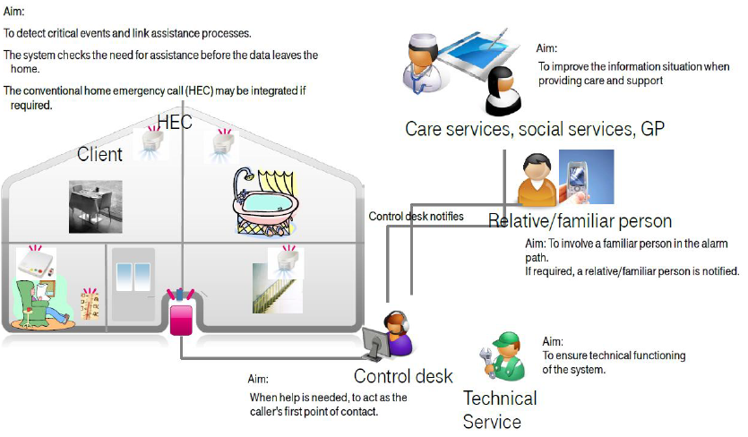

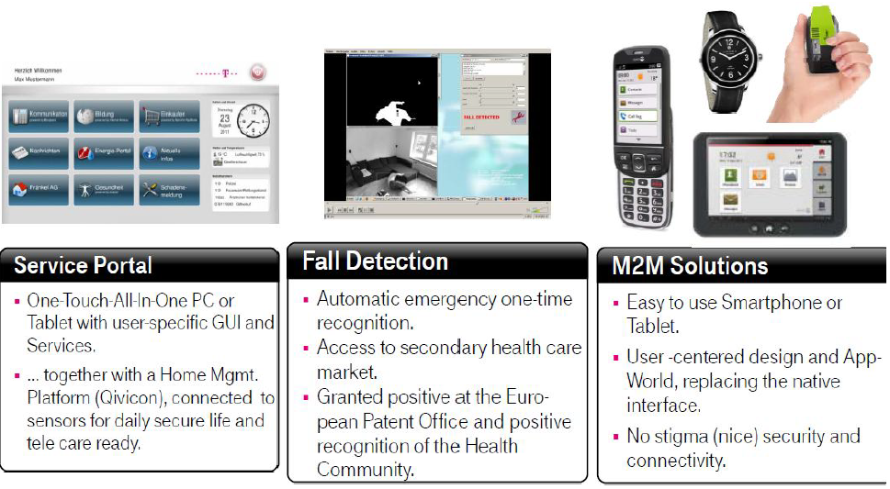
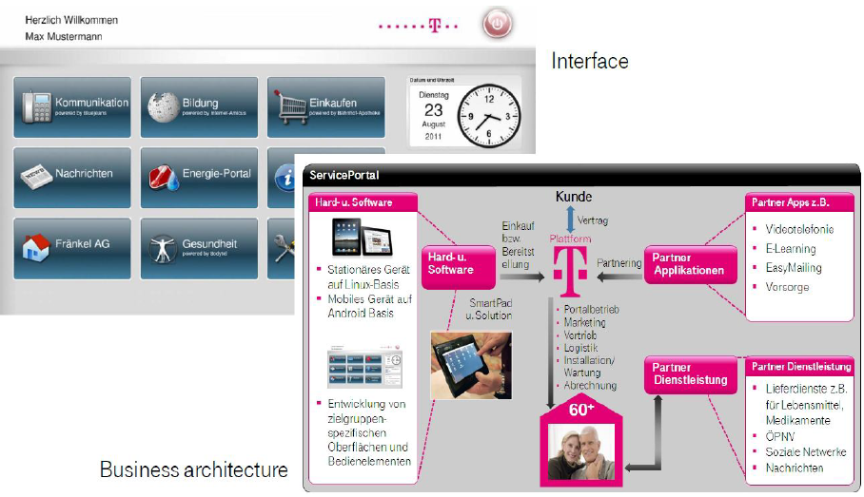

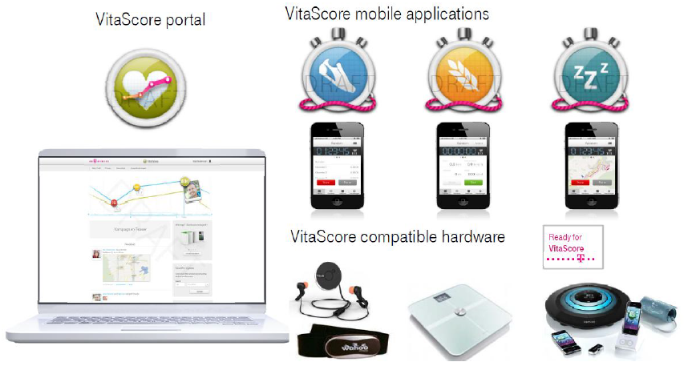

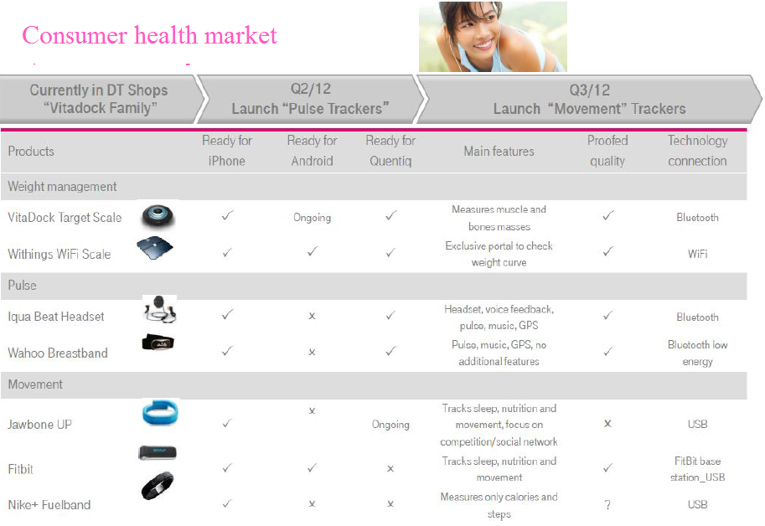

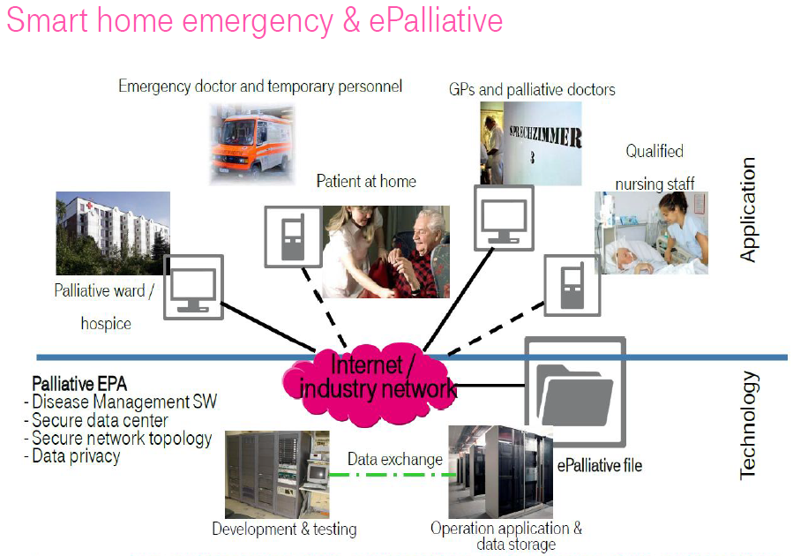
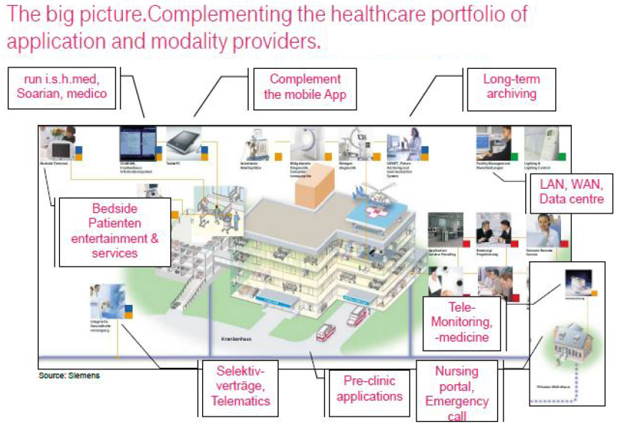

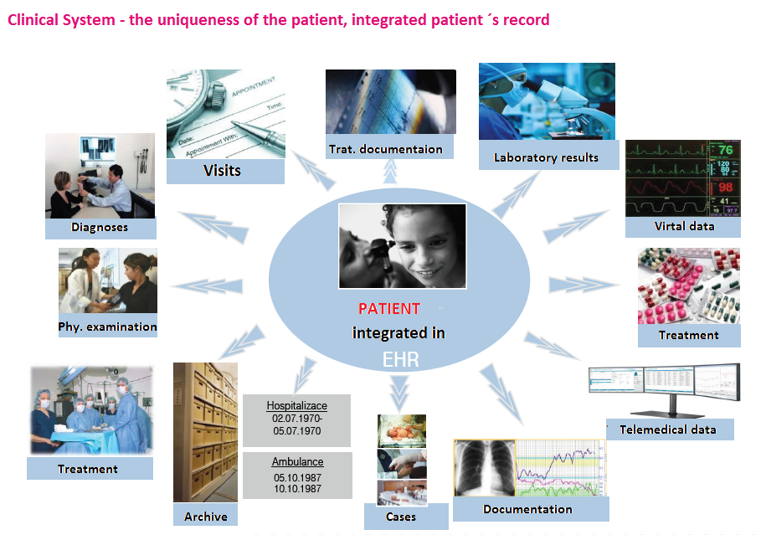
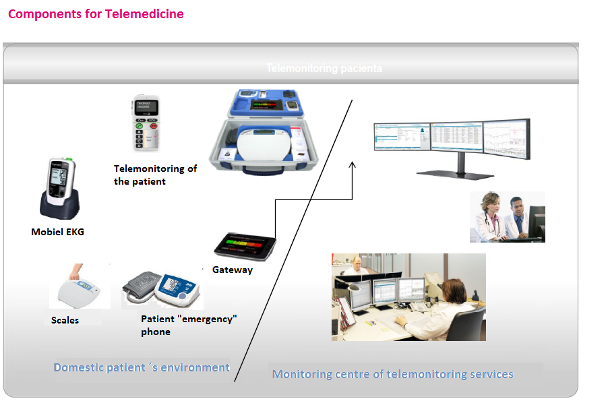

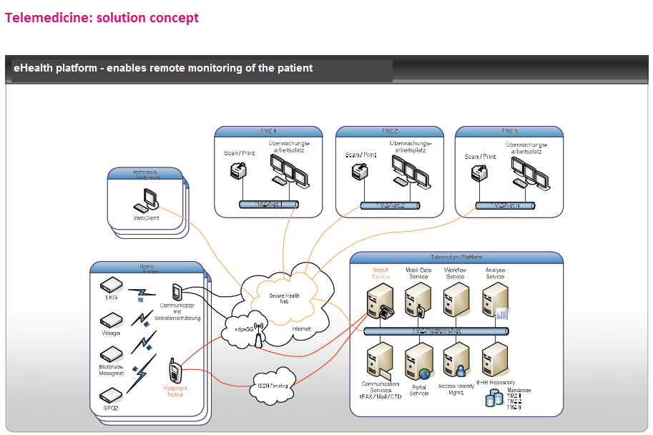
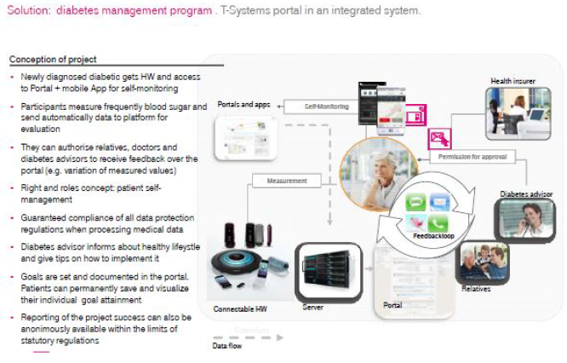
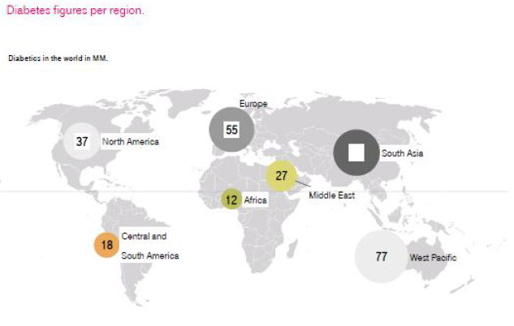

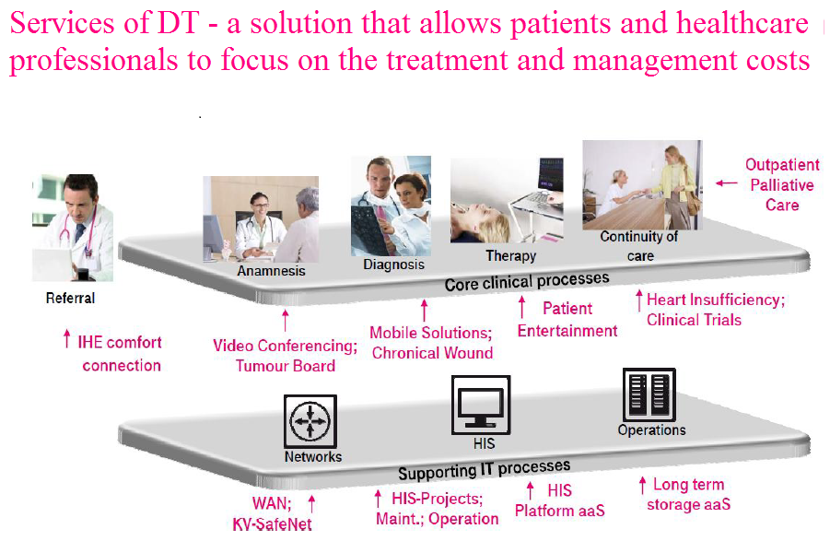
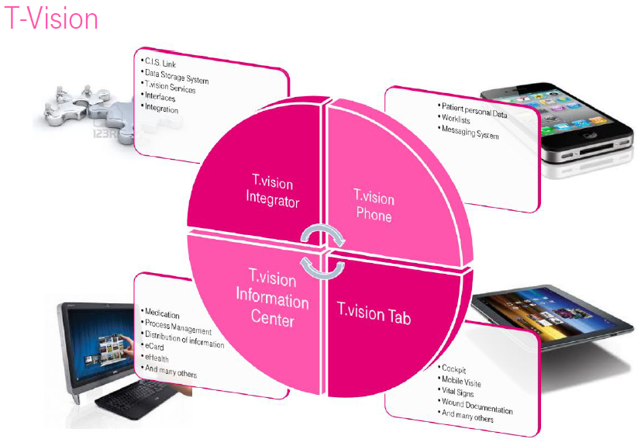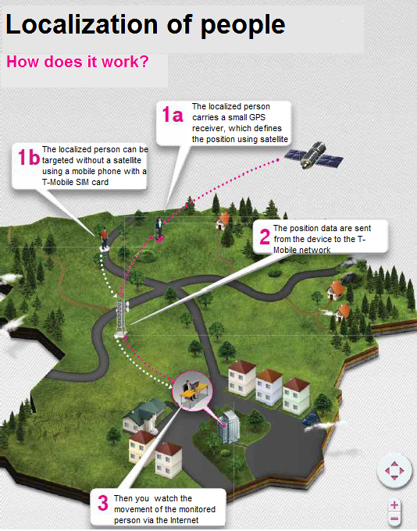
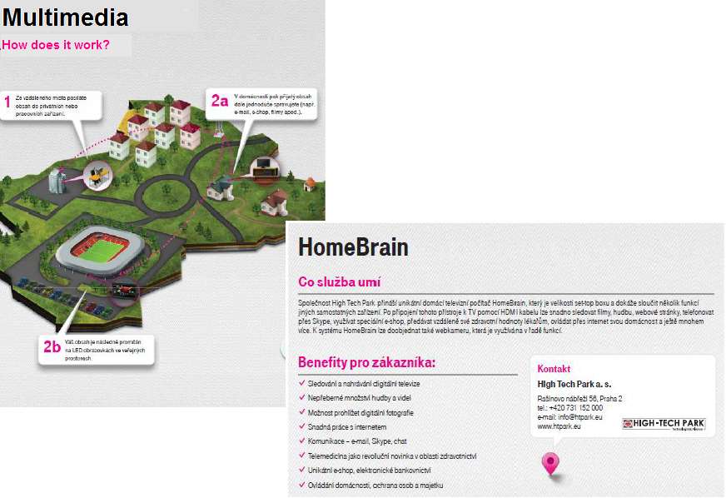
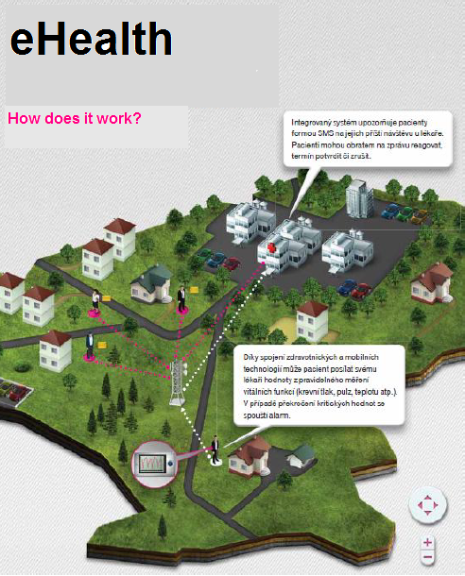

Payment of the allowance for care under conditions of the Czech Labour Office
Ing. Ondřej Piňous, Mgr. Šárka Důrasová
History
- 1990 – establishment of the independent labour offices. In the Czech Republic there are a total of 77 offices.
- LO headquarters in each district town. In some smaller towns there were established field offices.
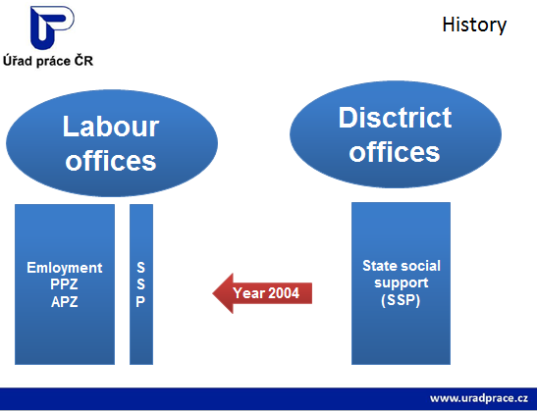

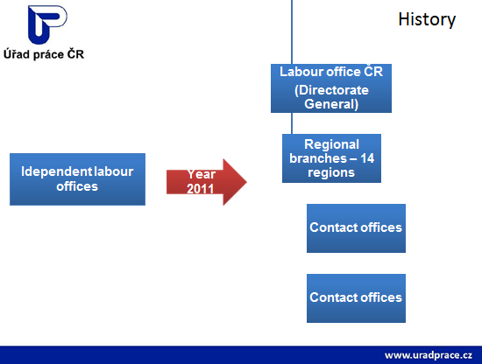
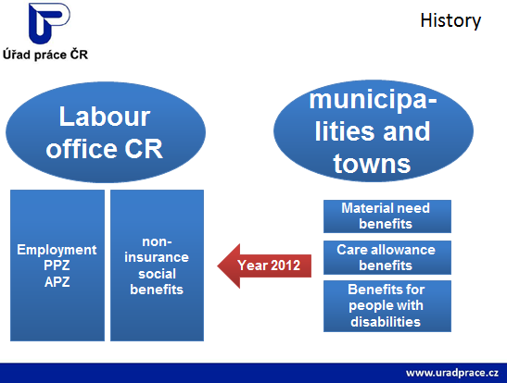
- Care allowance benefit is provided to persons dependent on the assistance of another person. By this contribution the state becomes involved in the provision of social services and other forms of assistance when coping with the basic life needs of people. Providing benefits is regulated by Act No.108 / 2006 Coll., on social services.
- For purposes of determining the amount of benefit we distinguish four degrees of dependency.
age/dependence degree | I. degree | II. degree | III. degree | IV. degree
Till 18 years of age | 3.000,-CZK* | 6.000,-CZK* | 9.000,-CZK* | 12.000,-CZK*
Over 18 years of age | 800,-CZK* | 4.000,-CZK* | 8.000,-CZK* | 12.000,-CZK*

* In specific cases, the possibility of increase by 2.000,-CZK

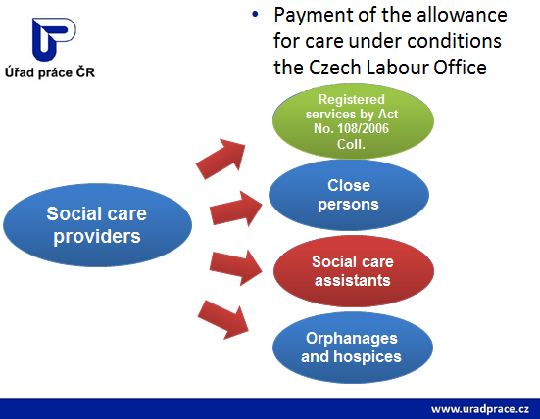

Development in the number of contributions for care benefits paid in the Czech Republic and the South Moravian Region
Area\average monthly payment of benefits | Year 2012 | Year 2013 | Year 2014 (till 30.9.2014)
Czech republic | 317 989 | 344 517 | 335 322
South Moravian Region | 37 507 | 41 146 | 40 230
Source:
JVM

The current situation in the field of social services in the city of Brno

- Financing social services and current trends

JUDr. Jitka Tesařová

Expenditure of the Statutory City of Brno 2013
CZK 10.8 billion
Operating expenses:
1. Transport 31%
State and local authorities 17,8%
Culture 9,8%
.
.
7. Social care 5,3%

Financing social services is multi-source.
- Subsidies from the city budget is only one of the sources
- Funding is in accordance with approved documents
- Medium-term planning of social services
- Interconnection of KPSS and financing of social services on the basis of close cooperation with NGOs → creation of a network of social services
the obligation of municipalities to co-fund social services
- Transition of funding from the Ministry to regions in 2015

BRNO – Department of Social Welfare of the City Hall
- subsidies for social services for NGOs - program I.
- subsidies for supplementary services for NGOs - II program.
- contribution of the founder to budgetary organizations
- ceded revenues to city districts (PS)

- MLSA grant proceedings for social services
- SMR grant proceedings to social services
    - IP Selected services of social prevention 2009 – 2015

- Structural funds of the EU (OP LZZ, OP VK, ROP, IOP)

- Other resources: Labour office, payments by the user, health insurance funds, domestic and foreign foundations, donations, membership fees etc.

Expenditure on social welfare in 2013 (in thous. CZK):
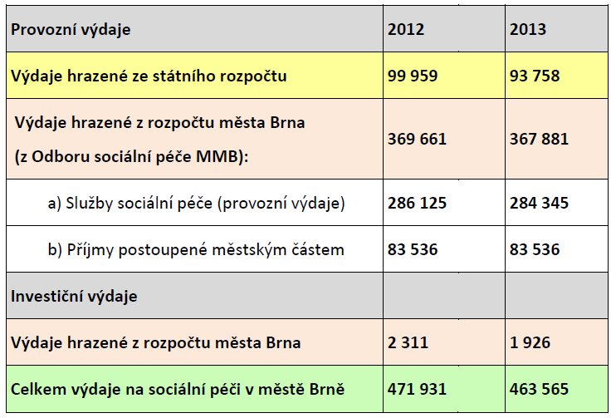

Financing of social services from the city budget 2011 - 2014
in thousands. CZK
 | 2011 | 2012 | 2013 | 2014
Contributory  organizations | 251 815 | 229 026 | 225 726 | 244 206 | 950 773
Non-governmental organizations | 44 200 | 44 200 | 44 200 | 47 200 | 179 800
Care service | 79 016 | 79 016 | 79 016 | 79 016 | 316 064
Total | 375 031 | 352 242 | 348 942 | 370 422 | 1446 637

Development of NGOs in social services and subsidies provided from the city budget
1992 | 12 organizations | 5 mil. CZK
2014 | 70 organizations | 47,2 mil. CZK

Sources of financing NGOs in 2013
in CZK
City of Brno (OSP) | 44 200 000
SMR | 22 937 280
MLSA ČR | 64 102 916
Funds EU | 8 774 792
Incomes from clients | 87 209 507
Funds of insurance companies | 1 836 720
Other resources | 25 104 987
Total | 254 166 202

Current problems
- The lack of social services for specific target groups - combined / multiple diagnoses
- Tackling housing problems with accompanying social services for certain target groups - the elderly, the disabled, the socially excluded, homeless people (shared housing, multi-stage housing)
- Aging of clients in institutions that care for people with intellectual disabilities or autism
- Employing people with disabilities and those at risk of social exclusion, including the issue of social entrepreneurship
- Solving the issue of carers (education, respite care)
- The need for linking social and health services
Solving the issue of overcoming barriers

Development trends
- More efficient use of existing resources - creating a minimum of social network. services
- Support for social prevention (outreach programs, NZDM, SAS)
- Emphasis on supporting clients to maintain their natural environment by developing outreach services
- Transformation in social services (deinstitutionalisation, humanization, ...)
- Social innovation - eg. new trends of housing
- Linking departments (social × health services, but also housing, education, housing department etc.)

- Social services in the city of Brno
PhDr. Zdenka Hašová
The mission of social care in Brno
- Help citizens in unfavorable situations through social work and social services
- Welfare reform in 2012 changed the status of municipalities in the social care system.
- A new definition of social work in municipalities aimed at specific target groups: families with dependent children, the elderly, the disabled, people at risk of social exclusion - counselling, social screening, work with clients in their natural environment, help in difficult life situations, including mediating contacts with relevant institutions.
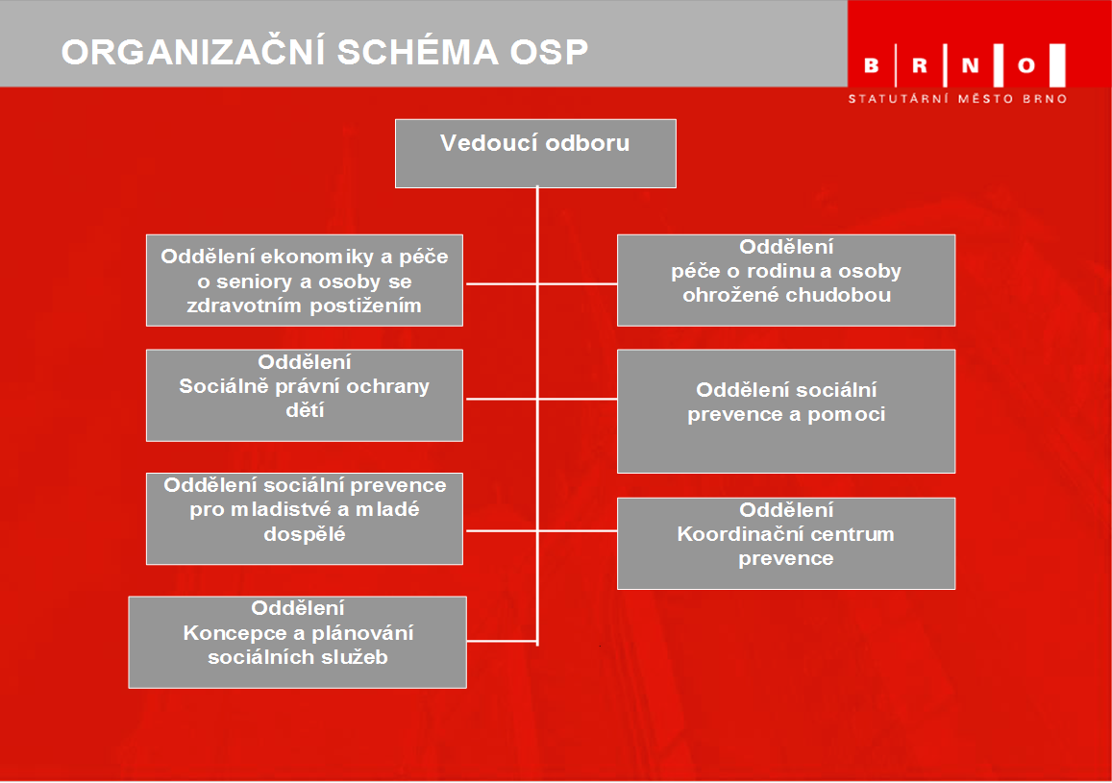
Social services (according to the Act No.108/2006 Coll.)
- Social counselling
- Social care services
- Social prevention services

Forms of providing the services:
- Residential
- Ambulatory
- Field

In 2013 there were 237 social services registered provided by 88 organizations (almost half of all registered social services throughout JMK) in Brno.

- The City of Brno - facilities for endangered children and youth (department of social prevention for youth and young adults of the Department of Social Welfare Brno City Hall).

- Contributory organizations - 11 homes for the elderly and Social Services Centre, contr. org. (+2 Contributory organizations MLSA).

- 6 day care centers in 6 boroughs.

- More than 70 non-governmental organizations and other entities.

- Community planning method as a tool for the development of the management and decision-making system on social services used in Brno since 2005.

- Community planning of social services (CPSS) based on the cooperation of all key stakeholders - advertisers, providers and users of social services (Triad) - the purpose is to organize such meetings on social services, which will result in an agreement on their development, or downturn.

- Community planning is a way of planning social services at municipal or regional level to fit local specifics and needs of individual citizens.

The aim of planning are social services, which
- are available (in terms of capacity, place and time,…)
- of a high quality and
- react to needs of users, appropriately to community options
- clear and understandable range of social services (directory, web portals ...)
- financing only those services that are actually needed

- one of the outcomes of the services planning process is a medium-term strategy in the area of social services - community plan for the period - one of the instruments for financing social services.

So far there are 3 community plans of social services processed in Brno, which for the period in question:
- Describe the current situation of social services in the city.
- Ascertains the needs in the area of social services (user needs analysis, sociological studies).
- They compare the existing supply of social services to the identified needs of users.
- They formulate the priorities in social services.
- They outline the trends, hitherto unsolved problems and areas.
- They represent the starting point for financing social services.

Specifics of CPSS in Brno:
- Catchment area.
- CPSS interconnection and social service funding.
- The web site of social care: www.socialnipece.brno.cz,
- Socio-information centrum:
  - launch of the activity on 1 October 2009 under the OSP MMB
  - the mission is to provide comprehensive information about the offer of social services and provide personal services, telephone and internet counselling from social and assistance in difficult situations
  - an advisory place (in 2013 guidance provided to nearly 6,000 clients)

The aims of 3. community plan:
- effective, quality and available social services.
- support and maintenance of the existing network of social services
- possible development according to priorities and measures

In the planning of social services the city of Brno works closely with the South Moravian Region at:

CREATING A NETWORK OF SOCIAL SERVICES
- Optimize and stabilize social service networks
- Sustainable and equitable financing
- The emphasis on quality in provision of social services
- Duty to co-finance from municipalities at the registration of new social services

METHODOLOGY FOR EVALUATION OF SOCIAL SERVICES
- Tool for evaluating social services
- Enables comparison of individual services
- Transparency for their evaluation

The non-profit sector and social services
Jaromír Hron

NGOs as a service provider
- Providers of all kinds of basic services - social counselling, social care, social prevention in all forms- outreach, outpatient, residential
- Legislation in the Czech Republic - law 108/2006 Coll. and related legislation
- 2014 - a turning point, an amendment to the Social Services Act relating primarily to the transfer of funding to the regions

In what ways are NGO´s different?
- Motivation – „positive deviation“
- Financing – multi-source, services are not set in order to make profit, but only for themselves, therefore for the needs of the clients.
- Efficiency - due to under-funding NGOs are forced to work efficiently and effectively
- Uncertainty - results from the unequal status of NGOs and donor organizations, when implementing the same services the conditions for funding and sustainability are not well set
- Cinderella - NGOs often work with those who are not wanted by anybody else and for minimum funding

ANNO SMR – multibranch roof
- It associates 101 NGOs from all regions, the social branch too
- It was established in 1998 as an association of NGOs Brno, in 2006, it expanded its scope to the whole area of the region
- The Association does not work on a sector base but on a cross-section - horizontal base
- Allows in many cases wider view to solving problem areas by linking sectoral aspects with general ones
- Thanks to networking of NGOs, a better cooperation is possible on cross-cutting topics
- One of the objectives is linking the non-profit sector with the state and local government and the private sector
ANNO SMR – support of the social sector
- It promotes an effective partnerships among government, local governments and the non-profit sector
- An example might be the participation of democratically elected representatives of NGOs in the commissions of the SMR Council
- When dealing with general topics relating to the non-profit sector it is not burdened unnecessarily by branch ballast
- BUT MAINLY IT IS A WATCHDOG, WHICH MAKES SURE THAT NGOs AND ALSO THE SMALL ONES ARE NOT FORGOTTEN
What except services do NGOs implementing social services contribute?
- Retraining - providing practice for participants of retraining courses
- Cooperation with the Labour Office when implementing projects supporting the creation of jobs
- New innovative project intentions awaiting funding opportunity
- Implementation of philanthropists
- Good basis for smelting of social entrepreneurship

Social services in the South Moravian Region
Mgr. Blanka Mikaušová, Mgr. Alena Novotná

Legislative framework
- Law no. 108/2006 Coll., On Social Services.
- MLSA Decree no. 505/2006 Coll., implementing certain provisions of ZSS.

Role of the region:
- Conditions for the admission (registration) + keeping the network (financing) + planning the development of social services (needs, characteristics, available resources, interconnection services, national and European strategies).
- Cooperation with key actors in the field of social services (MLSA, communities, providers, users).

Principles of providing social services
- An instrument of help and support for people in an unfavourable social situation with the aim to include them in the society or to prevent their social exclusion.
- The extent and form of assistance must always preserve human dignity, ensure respect for human rights and freedom of service users, and it must be based on their individual needs and actively promote their independence.

Conditions of registration social services
- Provider of social services is a natural or legal person who is authorized for this activity - registration (§ 78-82 ZSS).
- Conditions for issuing decision on registration by the regional authority (according to the seat of PO or permanent residence FO), or MLSA:
  - submitting a written request with all the requirements set by ZSS (§ 79 para. 5 ZSS).
  - professional competence of FO directly providing SS (§ 110 paragraph. 4.5, § 116, paragraph 5, § 116a, § 117 / a social worker, a social service worker, a medical or, a pedagogical worker, a marriage and family counsellor, another specialist).
- Clean record of PO and FO directly providing SS (§ 79 para. 2).
- Ensure hygienic conditions in social service facilities (§ 34 ZSS).
- Ownership or other right to a building, premises, where SS will be provided.
- Ensuring the material and technical conditions corresponding to the type of provided SS.
- The fact that the assets of the registrant have not been declared bankrupt or insolvency proceedings have not been imposed or bankruptcy petition has been dismissed for the lack of assets of the debtor.

Application for registration of SS
- Basic information about the applicant (FO / PO / org. body of the state, USC): name, surname, permanent address, date and place of birth/ name, ID address, statutory authority/ name, address, ID founder, name and surname of the manager OS).
- Data of provided SS (name and place of the facility, the venue for SS; type / s of provided SS, range of persons and their age; a description of the implementation of providing SS, description of staffing, time range for providing SS; capacity; plan for financial security; a method of providing health care - TS, DOZP, DPS, DZR, the starting date of the provision).
- Proof of clean record FO or PO.
- Documents providing professional competence of FO directly providing SS.
- The decision approving the operating rules issued by public health authorities (just for TS, DOZP, DpS, DZR)
- An extract from the LV, rental agreement.
- With PO certified copies of all required documents, lists from the business register if necessary.
- Documents proving the absence of tax arrears, arrears in payments and penalties for the VZP and the premiums and penalties on social security and contribution to the state employment policy
- An affidavit that the applicant's property has not been declared bankrupt ...

Obligation of the provider to make an insurance agreement against liability for damage caused when providing SS before commencing providing SS.
Duration of registration
- The decision shall expire in case that the provider does not begin to provide SS within 6 months from the decision.
- The registration is non-transferable, it shall cease to apply when PO expires, or by death of FO.
- KrÚ will decide to cancel the registration:
  - provider ceases to satisfy the conditions (§79 and §80 ZSS)
  - imposition of sanctions for administrative offenses because of a particularly serious breach of duties (§ 88 ZSS)
  - failure to meet quality standards (§ 99 ZSS), there was no correction not even on the basis of the measures imposed upon inspection
  - provider asks for a withdrawal of registration

Information for registrations
- procedure for submitting an application for registration of SS available at http://www.kr-jihomoravsky.cz/
- list of social services available at http://iregistr.mpsv.cz

Registration is not required
- providing assistance by a close person or a social care assistant.
- providing SS in health facilities of inpatient care (§ 52 ZSS).

Registered SS in the SMR
ZSS defines 33 kinds of SS divided into three categories:
- social counselling
- social care services
- social prevention services

On the September 1st 2014 there were in total 547 registered social services in the SMR, compared to 2011 there has been an increase by 24 services.

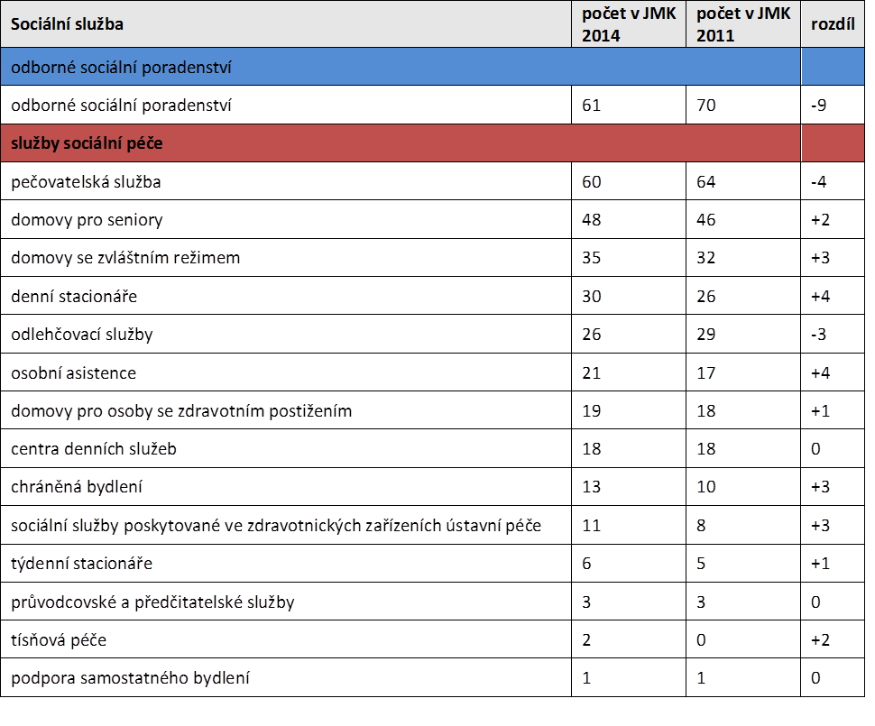

Registered SS in the SMR
- social care services (54%)
- social counselling (11%)
- social prevention services (35%)
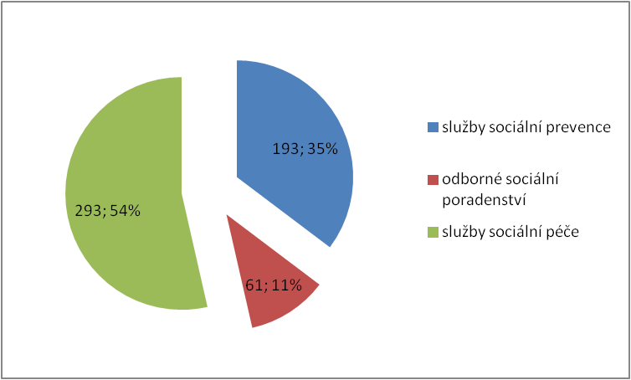
Registered SS in the SMR
According to the forms of provision:
- outpatient (268)
- field (230)
- inpatient (190)

Providers: total 167
The most numerous representations: NNO (89)

Providers of SS in the SMR according to legal personality
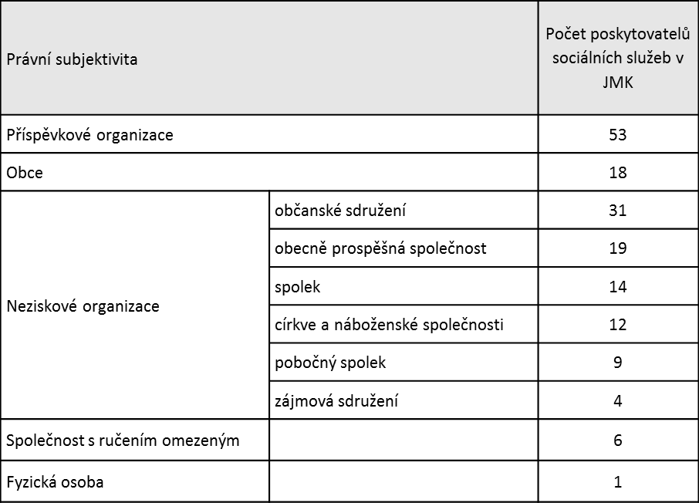

Providing SS without registration
- Legal or a natural person commits an administrative offense by providing social services without authorization (registration).
- A fine up to CZK 1,000,000.
- In the SMR there are about 10 services without authorization that provide DpS, DZR.
- In reality there are three basic methods of providing SS without registration:
  - providing SS entirely without registration on the basis of cumulation of trade licenses
  - provision of residential care services on the basis of the field service registration
  - providing SS through social care assistants, whose activities are organized or mediated

The definition of social services network in the SMR
- The priority for the year 2015 will be a delay and optimization of the existing network of social services.
- All registered social service facilities in the South Moravian Region are included in the supported social services network in SMR, which meet the following criteria:
- Consistency of the service and the medium term development plan of social services and its implementing annex - Action Plan development of social SMR services.
- The condition of municipal co-financing.

The condition of municipal co-financing
- Social services of professional social counselling - at least 5% of the cost (in case of failure the service criterion is assigned to category B, the amount of services support in this category will depend on the percentage obtained from co-financing and resources available in a given year)
- All registered social prevention services - at least 20% of the service cost
- Social services that arose and entered the financial system after January 1, 2012 - is declared / annually realized the participation municipalities / communities to cover the cost of 10-20% depending on the type of social services through the provision of services and the necessity identified within the territory of SMR
- Participation of 20% for social services prevention, department of social counselling and residential services (outside protected housing).
- Participation of 15% ambulatory services of social care.
- Participation of 10% for field services of social care, for protected housing services.

Financing of social services in SMR
- Social services, which meet these conditions are included in the supported regional network of social services and are funded on the basis of the evaluation outcome according to the methodology for the assessment of social services in the SMR.

METHODOLOGY OF EVALUATION OF SOCIAL SERVICES IN RELATION TO NETWORK OPTOMIZATION OF SOCIAL SERVICES IN THE SMR
  - takes into account quantitative and qualitative criteria
  - allows you to compare the performance of individual services on the basis of predetermined criteria, to which adequate weight is attributed
  - sets basic requirements for the quality and efficiency of services in the region.
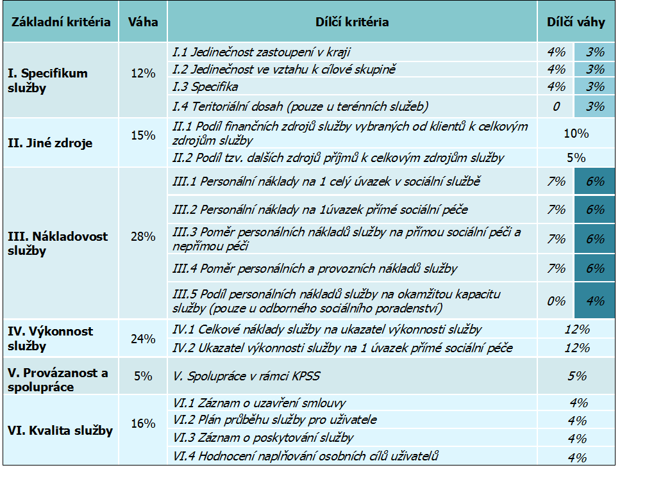

Subsidies for social services from the budget of the South Moravian Region
- Strategy of maintaining the existing system of social services is declared by the SMR by the volume of funds, which from its budget provides to fund social services.
- In the period 2005-2013, two subsidized programmes - support in the form of annual and multi-annual funding.
- From 2014 support of services through a one-year grant programme.
- In 2014 for financing of social services 51 mil. CZK were reserved.
- For 2015 it is planned to increase the amount.

Subsidies from the state budget
- Subsidies from the state budget - by the end of 2014 to be distributed through the MLSA.
- Aggregate claim for the year 2014 amounted to CZK 676,691,000 in the SMR (435 applications)
- The guide number stood at its result at 666 899 000 CZK.
- From 1 January 2015 transfer of grants for the region and the capital city of Prague.
- Grants are awarded to finance current expenditure related to the provision of social services.

Subsidy proceedings for 2015
The basic priorities of subsidy proceedings for 2015:
- Support field and ambulatory social care services that enable life of service users in their natural environment.
- Support of residential social care services implementing steps towards deinstitutionalization and humanization and support for social services resulting from or arising in connection with the process of transformation of residential facilities.
- Support of social services for persons with mental illness.
- Support of services for people with autism disorders, neurodegenerative disorders (esp. With Alzheimer's disease, Parkinson's disease), with multiple disorders and diseases with a low prevalence.
- Support to ensure continuous financing of social prevention services, individual projects funded by the counties.
- Support of policies and tenets of palliative care in social services.
- Support of adequate staffing in social services, particularly direct care workers (social workers and workers in social services).

Financing of social prevention services
- On January 1st 2015 80 social prevention services will be completed after 6 years of funding from the European Social Fund and the state budget under an individual project.
- The annual service costs were 194 mil. CZK.
- In the SMR there is currently approved continuing IP "Selected prevention of social services in the South Moravian Region", under which funding can be only in a part of 2015.
- For selected types of social prevention services (asylum houses, halfway houses, social therapeutic workshops, intervention centres).
- There is a total amount of CZK 69,320,800, which the region gained from European funds.

BETANIE – Christian Aid
Ing. Jirka Bednářová

Introduction to the problem
- Principles of welfare provision stated by Act no. 108/2006 Coll. since 1st January 2007
- Declares the division of social care according to provided operations incl. their payments
- The state through Labour Offices (formerly the Social Security Administration) provides citizens in need in a different extent with help of another person called Care allowance (Ca)
- Care allowance is divided into four levels of 800, 4,000, 8,000 and 12,000 crowns a month depending on the degree of help needed
- The recipient of these funds is a user who needs the service, and these funds are assigned to a person who provides the service.

History
Betanie – Christian Aid
- 1990 amateur conditions of help in households
- 1996 registration of civic association with MV ČR
- 1997 1 paid carer
- 1999 6 paid carers
- 2000 pre-project and project preparation of a construction of the House of Ageing Well in Brno-Maloměřice (DDS)
- 2001 – 2003 ensuring financial coverage of the construction
- 2002 building permit, the contractor SP (VŘ), laying the foundation stone, which was brought from Husinec, and beginning of the construction
- 2004 recruitment of employees and home clients, opening of the DDS
- 2006 transfer of the rectory of the CHC in Hrušovany near Brno
    - 2007 processing of the reconstruction project and applications for financial support under the Regional Operational Programme South-East, building permits
- 2008 approval of EU funding in the amount of 92.7% of the budgeted costs and the beginning of reconstruction of a house with a special regime Villa Martha
- 2009 recruitment of employees and clients, opening of Villa Martha
- 2011 transfer of unused Jan Hus Congregation in Lelekovice (dist. Brno-Country
- 2012 project preparation for the construction of weekly care centre
- 2013 settled zoning permit, preparation of documentation for building permits, elaboration of applications for financial assistance from EU funds
- Present time commencement of the provision of respite services; preparation of transformation process of the registered association with a registered institution 71 employees who take care of on average about 350 clients a year.

Field services
- 18 workers (nurses and carers).
- Day care - according to the client´s wish, who pays it from the contribution to the day care (shopping, errands, companionship, cleaning, hygiene, household chores) the rate of 130 CZK / hour.
- Health care - according to the doctor's instructions, paid by health insurance (stoma treatment, bandages, subscriptions, activation exercises)
- The care takes place in the home environment of the client
- Intensive coordination, big fluctuations in occupancy eg. sudden hospitalization of the client

The house of dignified aging started in July 2004
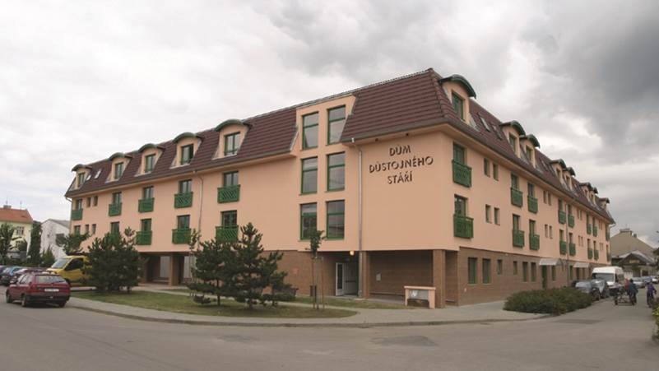

The house of dignified aging
- Home for the Elderly (according to the Act. 108/2006 Coll., § 49).
- Registered provider of social care and health services.
- Service 24 hours a day, 7 days a week.
- 75 clients in different degrees of dependence on the help of another person (degree of care allowances from I. - IV.).
- Various types of accommodation (bedroom apartments, dorms, double and triple rooms with intensive care) according to the current health status of the client so that he could stay in the home until his last days.
- 38 employees of which 22 in the so-called “Direct care “ (Carers, nurses).
- Short-term stays for seniors during periods of relaxation of family carers (holidays, apartment renovation, etc.).

Villa Martha
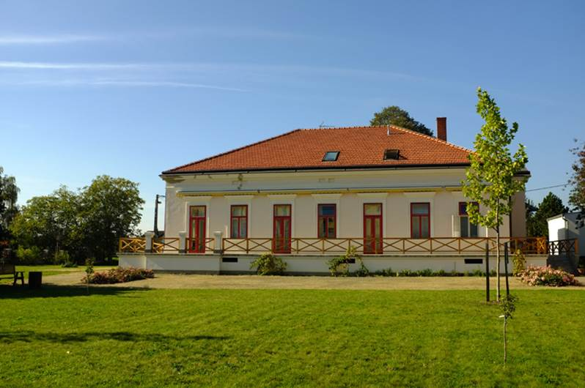

Villa Martha
- Special home (according to Act no.108/2006 Coll., § 50).
- In 2009 evaluated as the best project of the ROP Southeast.
- Care provided to clients with senile dementia and Alzheimer.
- 20 clients mainly in multi-bed rooms.
- 15 workers providing continuous care, including 12 direct care workers
- Good cooperation with local governments and the region of Židlochovicko.

Both boarding facilities
- Houses of prayer, in which regular worships take place not only for clients but also for believers from around
- On request funeral farewell to the deceased clients can be held in chapels.
- Occupational therapy regularly held physiotherapy and music therapy.
- Regular visits of a contractual physician; import of medicaments.
- Ensuring your own transport (eg. To a doctor) by wheelchair car.
- Regular joint anniversary celebrations of the month with a cultural programme.
- Joint celebrations of Christmas, New Year ´s Eve and other important holidays
- St. Nicholas´s feast, Three Kings, witch burning, discussions with projection etc.
- Organizing cultural events, cooperation with schools, the Brno Philharmonic Orchestra, the National Theatre of Brno.
- Mutual visits of clients of both facilities.

Respite services
- According to § 44 of Act No. 108/2006 Coll.
- In DDS there has been in operation a single room with a private bathroom
- Registration of respite services for about 9 clients with working hours from 7a.m. - 7p.m. on weekdays
- 1 carer + 1 nurse

Convalescent stays
- Organized since 1996
- Twice a year (spring, autumn).
- Not only for our clients, but also for public.
- Affordable weekly stays for seniors in mountain areas (Hostýnské hills ,Žďárské Hills) or in the spa (Luhačovice spa Lower Lipová).

Recondition stays
- A part of the stay is a daily reflection on the Scripture and exercise, and depending on local conditions also swimming in the pool.
- Cultural programme, trips, barbecue at a campfire and so on.

Weekly day care centre Lelekovice
- Creates project documentation for reconstruction of the weekly day care centre.
- It will provide social services to approximately 18 seniors on the weekday basis from Monday to Friday so that family carers are not excluded from economic activities
- A house of prayer will remain in the building for holding regular services
- We are looking for opportunities to finance investment (about CZK 15 million) from public sources (county, city, MMR, EU)

Vision of Betanie about care for the elderly
- Provision of basic social counselling, orientation in legislation, assistance with settling social contributions
- Home care, occasional home help to a more or less self-sufficient client, or in cooperation with the family
- Ambulatory care in a day care center or in weekly respite services, in case the senior needs help and increased supervision and the family cannot provide it during the day
- Placement in a residential facility, depending on health either in a separate apartment or dorm with intensive care at the nursing unit
- In case of diagnosed dementia, placement in special homes.
Financing the scheme
- Payroll costs including taxes make 76% of the total costs of the organization
- Covering of running costs
  - 68% revenue from services rendered
  - 28% public subsidies
  - 4% financial donations
- Betanie management - Christian Aid is balanced and its gross annual turnover is 30 million.

Training activities
- We provide employees with upgrading of skills in the context of lifelong learning through cooperation with accredited tutors
- We provide the possibility of practical training of trainees at our facilities (GCSE practical vocational secondary schools, required training of retraining courses organized by the Labour Office).

Cooperation with volunteers
- Our facilities are open to cooperation with volunteers, whether from among the members of the CHC, possibly Jewish community in Brno, but also students who come back to us after completing their professional training.

The provision of social services in Slovakia – the basic principles
Ing. Jarmila Boháčová, Ing. Alena Čemanová

Social services
Social services are a form of social assistance for people in unfavorable social situations. The state promotes social inclusion and meets the social needs of people in unfavorable social situation through them.

Focus of social services
Prevention of rise, solving or mitigating an adverse social situation of an individual, family or community, conservation, restoration and development of the individual's ability to lead an independent life, supporting inclusion of individuals in the society, prevention of social exclusion, addressing a critical social situation of the individual and the family.
A part of the support of social inclusion of persons in adverse social situations is also the issue of socially excluded communities. Within the scope of this activity, the ministry coordinates state policy, develops strategies and policy documents, analyses and legislative intentions, and coordinates policies with other relevant areas in the interests of social integration of socially excluded communities. It also prepares draft legislation on the development of living conditions of socially excluded communities.

The national development priorities of social services
National development priorities of social services for the years 2009 to 2013 were a reflection of the real situation of social services in the Slovak Republic. They are based on the needs identified within the country and at the same time within the priorities of the European Community.

National development priorities of social services of the SR
Support of the client's residence in the natural environment by developing field social services, development of outpatient social services and social services in residential facilities with weekly residents, improvement of the quality and humanization of provided social services through reconstruction, extension, modernization and building of social service facilities and education of employees in social services.
Deinstitutionalisation of social services
The aim of the deinstitutionalization is to create and provide conditions for free and independent life for all citizens in need of assistance in a natural social environment of the community. This can be achieved by means of complex, high-quality alternative public services, enabling them to live free and independent lives with the support of the community, professionals, family members and volunteers. Expansion of alternative options for meeting the needs of children who have been deprived of parental care will be important too.
The Slovak Republic joined the global trend of systematic elimination of the consequences of the institutional isolation model and segregation of people requiring long-term support and care in specialized institutions at the end of 2011. Such a change in the model is one of the objectives of the current European Union policy in the field of social inclusion and disability and is a part of the obligations of the Slovak Republic in the international human rights agenda. On 14th December 2011 Ministry of Labour, Social Affairs and Family of the Slovak Republic approved the National Action Plan for the transition from institutional to community care in the social services system for the years 2012 - 2015.

The offer of social services
The citizen has the right to choose social services and the form of its provision and the right to choose the provider of social services.
The type of social services, the form and extent of its provision shall be determined according to the social situation or the dependency of the person on the help of another person.
The unfavourable social situation is a threat to an individual with social exclusion or limitation of their ability to integrate socially and solve their own problems:
- because they do not have necessary conditions to meet the basic needs of their living habits or the way of life, drug addiction or harmful activities, risk of their development because of their disability in case of children under seven years of age,
- severe disability or poor health,
- because they have reached the age of retirement
- for taking care of a person with severe disabilities,
- for being at risk due to other peoples´ behaviour, or being a victim of behaviour of other individuals
- when staying in spatially segregated localities with the presence of concentrated and generationally reproduced poverty.
Social services of crisis intervention
Social crisis intervention services are provided for individuals to address a variety of adverse situations (eg. accommodation, food, essential clothing and footwear and basic personal hygiene, domestic violence, living in a village), through field social services of crisis intervention, low-threshold day centres, integration centres, community centres, hospices, shelters, halfway homes, low-threshold social services for children and family and emergency housing.
The above mentioned social services and facilities do not differ only by their names but they also depend on whether and how the natural person has decided to solve their situation. Wider choice and better quality in a form of eg. housing or other activities for the client can make a significant shift towards normal integration (eg. from the hostel where they sleep only sporadically and otherwise spend most days in the street, the choice of a shelter where they can live for some time, and receive other forms of support). The obvious difference is eg. between shelters, hostels and halfway homes. As hostels and shelters provide a social service to clients who do not have the necessary conditions to meet basic needs, halfway homes are aimed at individuals who do not have accommodation for reasons specified by law (eg. after staying in an orphanage, social service facilities or after release from imprisonment). Emergency facilities also provide housing, but to different clients. This concerns for example. a natural person, who has been a victim of violence or a victim of human trafficking. It is therefore a very specific target group of social intervention.
Prevention and protection against the abuser or other dangerous persons is to ensure confidentiality, accommodation and anonymity of natural persons in emergency shelters in case the persons have been victims of violence or human trafficking. For individuals who do not have basic needs provided (e.g. the homeless) a low-threshold day center is opened, in which these persons may reside also during the day, not only at night (e.g. in the dormitory). In such a facility there is, moreover, enough space to assist in the implementation of rights and legitimate interests of the client. The device also provides the type of mandatory support.

The social services to support families
Services to support families in unfavourable social situations are treated separately. The law defines assistance with personal care for a child who was under the previous legislation in the form of home care services. This assistance provides social work activities in situations where the child's parent or so-called substitute parent for various reasons cannot take care of their child.
The law on social services in the field of reconciliation of work and family life sets support measure on providing ambulatory and field social services to those parents with children who are interested in professional growth or carry out other activities in order to begin work or return to work. Therefore, at the time the parent participates in e.g. retraining course, there are various social service providing childcare and household offered (eg. food, personal hygiene, dressing, preparing for school lessons, escorting to school or leisure time activities).
Residential service is a temporary children care facility, which provides social services to the child if a parent or legal person who has the child in care cannot take care of them for serious reasons (e.g. due to illness, accident, spa treatment, childbirth, admission to custody or imprisonment).
In order to ensure the protection of children's rights, the provision of personal care and services in our temporary childcare is possible only if in addition to the already mentioned reasons, there are other serious reasons in the family for which it would be necessary to implement measures within the social and legal protection (e.g. risk of psychological, physical and social development of the child).
With effect from 1st January 2014, a social service - a service of early intervention was included in this group of social services. This social service is aimed at children with disabilities up to seven years of age and their families, because without the necessary assistance there may be a threat to a complex child development and also to the risk of social exclusion of the child and his family. As a part of this service a number of professional activities will be provided, such as specialized counselling, social rehabilitation, various preventive activities and performance of different stimulation methods and techniques to address sensory and motor stimulation. The aim of these professional activities is in line with the holistic approach to ensure optimal development of children with disabilities. Early intervention service may be provided through an ambulatory or field service, for example. directly in the household the child with a disability lives.

Social services to address the adverse social situation due to severe disability, ill health or because of reaching the retirement age
Social services
Social services are designed for:
- individuals dependent on the assistance of another person because of severe disability,
- individuals with a definition of the type of disability and
- the elderly.

Nursing service
It is a mandatory field social service, which provides people in need with assistance from another person whose reliance must be at least of II. degree. Dependence is assessed by an appointed doctor.

Transport services
Transport services are provided to persons with severe disabilities who are dependent on individual transport and to persons with poor health affecting their mobility and orientation. In practice, this means that from the transport service may also benefit people who have mobility problems for a short period (eg. the leg fracture). Proving poor health for the purposes of transportation services is very simple. The client demonstrates this fact by confirmation from an appropriate doctor. Reliance on individual transport by car is demonstrated only by confirmation issued by the competent authority of Labour, Social Affairs and Family to compensate for the social consequences of severe disability.

Tourist guides and reading
Tourist guidance and reading services can be provided as a separate social service, and not just as one of the acts of care services. In addition to persons who usually need escort and reading services (blind people), it is possible that social services are provided to persons with mental disabilities. The escort is provided to medical examinations, sorting out official matters, to school, from school, to work, from work and spare time activities.

Interpretation service and personal assistance
Other social services are interpretation service and personal assistance. Both of these social services, even when they are provided to different target groups, they may also be provided through agencies specializing on those activities. Their provision, however, may be one of several activities of a relevant entity, for example. civic association or non-profit organization, providing them without setting up an agency. Agents of interpretation services are available to those in need of interpretation. It is intended for personal assistance to individuals with severe disabilities who are dependent on personal assistance. It makes no difference whether they are also provided with cash allowance for this purpose.
Rental equipment
A group of persons entitled to that kind of social assistance is defined quite broadly. These are people with poor health leading to dependence on the device for a certain transitional period. Other conditions are not stated in detail, so that the providers can choose a method that will suit the needs of the clients, the region and themselves. A natural person with a severe disability demonstrates the need for this service according to the Law on cash benefits to compensate for severe disability.

Social services using telecommunications technology and emergency assistance
These social services include monitoring and indication of the need for assistance (communication via signalling devices or audiovisual devices connected to the central control, f.g. bracelet to signal the need for assistance) and emergency assistance through telecommunication technologies (e.g. telephone hotline, via email).

Support services
Relief service
This social service is only for natural persons - caregivers who provide care in the context of care allowance. When family caregivers are provided with relief intervention, the person in care receives other social services (eg. nursing service). During these days the caretaker can realize their programme and plans (vacation, personal equipment issues, meeting with friends). Such “time off” is provided for 30 days in one calendar year and may also be taken intermittently by individual days, but not by hours. While providing caretaker with the relief service, they will continue to receive cash benefit for care in full. Help Your Loved One may be provided directly in the home (nursing home), or in day-care or residential facilities.

Assistance in the exercise of guardianship rights and responsibilities
The aid lies mainly in providing or arranging social and other professional advice counselling by court appointed to the guardian.

Day Centres
Are former clubs for pensioners, that in addition to older people and those of poor health or with severe disabilities, parents with children or grandparents with grandchildren can attend these centers as well. Day care centers not only provide interesting activities, but they also provide social counselling.

Support for independent living
Within the support services a new type of social service is provided, which is to promote independent living. As part of this service natural persons may be involved in a variety of adverse situations for which different kinds of assistance directly in their natural environment will be provided(e.g. in the apartment). For example: assistance with housekeeping, management of funds when paying bills, organizing contacts.

Dining room, laundry, personal hygiene centers
Common feature of these social support services is that they provide the same range of target groups, namely people with severe disabilities or poor health, the elderly, and persons who do not secure the conditions necessary to meet basic needs.

Providing financial contributions according to the amendment to the Social Services Act
The amendment to the Social Services Act, which came into force on 01.03.2012, amended the new way of funding:
- municipals providing social services in selected types of social services or municipalities which have established or founded selected types of social services - hostels, shelters, halfway houses, emergency housing, temporary care facilities for children, assisted living, facilities for seniors, nursing care facilities, rehabilitation centers, social service homes, specialized equipment and day care centre ,
- legislative conditions for financial contributions to fund municipality social service facilities are regulated in § 71 paragraph. 6 and § 78b amendment to the Act on Social Services. The municipality puts forward a written request for a financial contribution to the Ministry of Labour, Social Affairs and Family of the Slovak Republic (hereinafter the "Ministry") to fund social service facilities according to § 71 paragraph 6 and § 78b amendment to the law on social services for the financial year in two copies no later than on 31 August of the previous financial year.
- Private providers of social services in selected types of social services - facilities for the elderly, nursing care facilities, day care centres, a dormitory.
Legislative conditions for financial contributions to ensure the provision of social services to private providers of social services, providing social services in selected types of social services community are governed by § 78a of the amended Act on Social Services. This financial contribution is financed from the budget of the Ministry.

Selected institutes of quality in social services

- Terms of rating the quality of social services
National legislation did not use the term quality standards till January 2014, but the term conditions of the quality of provided social services, which were evaluated in three areas:
- procedural conditions (focused particular on evaluation procedures, methods and rules for the provision of social services, development, evaluation and review of individual development plan clients, creating conditions for their activation, for their expression to the level of service),
- personal conditions (e.g. assessment procedures and the rules for recruitment their education, evaluation, and providing supervision),
- operating conditions (e.g. equipment and accessibility of the service provider´s environment, respect for human dignity, management, transmission, processing and documentation of information).
The competency evaluation in terms of the quality of social services under applicable law MLSAF. MLSAF is bound to carry out specific competence assessment of the conditions of social services quality through authorized civil servants and outside experts for each area of evaluation. The beginning of exercising this competence, however, is shifted to the year 2016 with regard to the difficult conditions of the overall cover of social services during the economic crisis and its continuing effects.
This does not mean that by 2016, stakeholders should not pay attention to the issue of quality. It is necessary to interconnect a model based on the evaluation, which will be implemented by the Ministry, with a model of continuous improvement of social services based on self-assessment of their providers.

- Qualifications and further education in social services
A part of quality of social services is qualifications of employees and workers who operate in them and ensurance of their permanent further education. Social Services Act defines the range of working activities within the field of social services and the qualifications needed for their implementation.
These are the following activities: basic and specialized social counselling, social work, supervision, care, interpretation, assistance with guardianship rights, working therapy, teaching social rehabilitation, coordinating the provision of social rehabilitation exercise activities. Similarly, it determines what qualifications must the educator, educational staff, a medical staff member or a person who performs medical assessment activity possess. A person who carries out social work or specialized social counselling must have a university degree exclusively in the field of social work.

- Accreditation of educational programmes
The quality of social services provided through quality lifelong learning for people who get engaged in it, has meraised the need for a new process of accreditation of educational programs. The new law on social services in this area has been a significant shift, which has been carried out in two directions:
- strengthening the competence of MLSAF as a government agency directly responsible for the area of social services in the accreditation process, as during the period of accreditation of educational programmes Ministry of Education previously carried it out also for the social region .
- by extending the accreditation requirements not only for educational programmes, but also for other professional activities, such as specialized social counselling and social rehabilitation.
In order to prepare documents and statements for decisions of the Ministry of Labour, Social Affairs and Family of granting or withholding a grant, of a change, extension or withdrawal of accreditation functions of the labour ministry since 2009 Accreditation Commission. It consists of representatives of state and local governments, non-governmental sector and university land.

- Volunteering in social services
An inherent part of social services quality is increasingly becoming a volunteer element. Volunteering in social services belongs to one of the most common areas of volunteering, which involves people of different ages.

Conclusion
Slovak Republic, during more than 20 years of its existence, has committed to the whole set of important human and legal international instruments. The entrance to the European Union has intensified our efforts to create conditions for the rights and fulfilling the individual needs of all citizens. Historical development from the beginning of the last century led to the creation of an institutional system of social services, which prevailed especially in the former communist countries. Similarly, in the care of children who can not grow up in their families, prevailed institutional approach and collective education.
Even now there are still several facilities with remains of institutionalization, which was maintained and strengthened in the second half of the 20th century, the influence of collective ideologies, giving the company and the state "doubtful law" and the power to separate certain groups of people from the rest of the society and restrict in particular their rights for personal liberty, self-determination, decision-making, independence, social participation, influence and choice of living conditions.
Despite the apparent effort to humanize social services, as well as improve assistance to childcare and families with children who for various reasons can not grow up in a natural family environment, the changes that have been achieved in recent years can not move the center of gravity to help and care more strongly in favour of the citizen - to the fulfilment of their rights, individual needs and creation of the prerequisites for independent living in an integrated community of full citizens. The current focus of EU social policy, as well as current developments in international human rights agenda highlights the need to change the system of institutional care prevalent in the Slovak Republic - deinstitutionalising and transforming it into a system with a predominance of services and measures provided in natural communities organisationally and culturally the most similar to normal family. It is no longer possible to ignore the fact that institutional care with collective approach leads not only to traumas and negative impacts on health and personal development of the individual, but also to social exclusion, helplessness, passivity and inability of full citizenship.

Sources:
- Ministry of Labour, Social Affairs and Family
http://www.employment.gov.sk/sk/rodina-socialna-pomoc/socialne-sluzby/
- Ministry of Labour, Social Affairs and Family SR
http://www.employment.gov.sk/sk/rodina-socialna-pomoc/socialne-sluzby/ponuka-socialnych-sluzieb/
- Services targeted quality
http://www.ivpr.gov.sk/IVPR/images/pdf/2014/socialne_sluzby_kvalita.pdf
- Strategy deinstitutionalisation of social services and foster care in Slovakia republic
http://www.employment.gov.sk/files/legislativa/dokumenty-zoznamy-pod/strategia-deinstitucionalizacie-systemu-socialnych-sluzieb-nahradnej-starostlivosti-1.pdf

Sources

The Association of NGOs of the South Moravian Region [online]. 2014 [cit. 2014-12-03]. Dostupné z: http://www.annojmk.cz/

Directorate the Labour Office. The Labour Office of the Czech [online]. [cit. 2014-12-03]. Dostupné z: https://portal.mpsv.cz/upcr/gr

Department of Social Welfare of the City Hall. The South Moravian Region Portal [online]. [cit. 2014-12-03].
Dostupné z: http://www.kr-jihomoravsky.cz/Default.aspx?ID=18642&TypeID=2

Portal of the Social Welfare in Brno. [online]. 2009 [cit. 2014-12-03]. Dostupné z: http://socialnipece.brno.cz/

Presentation by participants.

